Access Point (AP)

📡 What is an Access Point (AP)?
# Source: AI Source: Provided by: [Data Path: Persons Table -> ID Column: 1, Name_En Column: Motasem Essam] -> From: [ChatGPT] on [12/18/2025]
An Access Point (AP) is a network device that allows Wi-Fi devices (like smartphones, laptops, or smart TVs) to connect to a wired network. It acts as a bridge between wireless clients and the wired LAN (Local Area Network).
Think of it as the Wi-Fi transmitter in your office or home network.

Access Point (AP) Image
# Source: ScreenShots Source: Provided by: [Persons Table -> ID Column: 1, Name_En Column: Motasem Essam] -> Tool: [Lightshot Program] -> From [Site: Google Search: Images: Access Point (AP)] on [12/18/2025]
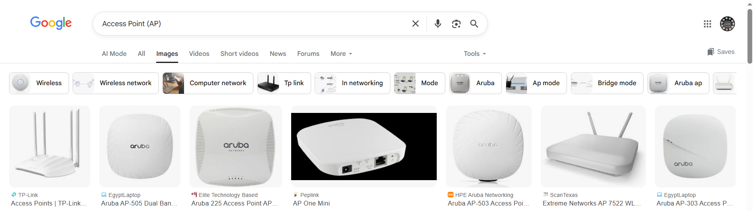

🔄 What an Access Point Does
# Source: AI Source: Provided by: [Data Path: Persons Table -> ID Column: 1, Name_En Column: Motasem Essam] -> From: [ChatGPT] on [12/18/2025]
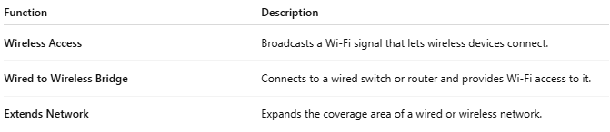

Function | Description
Wireless Access | Broadcasts a Wi-Fi signal that lets wireless devices connect.
Wired to Wireless Bridge | Connects to a wired switch or router and provides Wi-Fi access to it.
Extends Network | Expands the coverage area of a wired or wireless network.

🧱 Basic Network Diagram
# Source: AI Source: Provided by: [Data Path: Persons Table -> ID Column: 1, Name_En Column: Motasem Essam] -> From: [ChatGPT] on [12/18/2025]
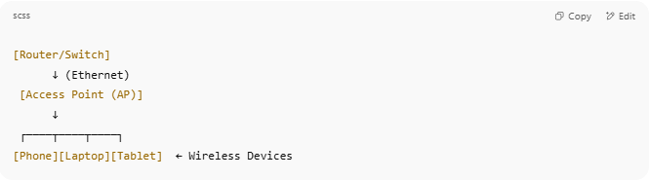

[Router/Switch]
↓ (Ethernet)
[Access Point (AP)]
↓
┌────┬────┬────┐
[Phone][Laptop][Tablet] ← Wireless Devices

- The AP is wired to the network and broadcasts a Wi-Fi signal to nearby devices.

🔧 Key Features
# Source: AI Source: Provided by: [Data Path: Persons Table -> ID Column: 1, Name_En Column: Motasem Essam] -> From: [ChatGPT] on [12/18/2025]
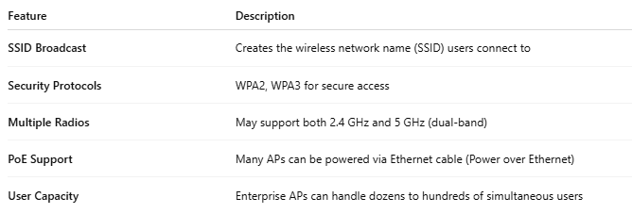

Feature | Description
SSID Broadcast | Creates the wireless network name (SSID) users connect to
Security Protocols | WPA2, WPA3 for secure access
Multiple Radios | May support both 2.4 GHz and 5 GHz (dual-band)
PoE Support | Many APs can be powered via Ethernet cable (Power over Ethernet)
User Capacity | Enterprise APs can handle dozens to hundreds of simultaneous users

🆚 Access Point vs Router vs Wi-Fi Extender
# Source: AI Source: Provided by: [Data Path: Persons Table -> ID Column: 1, Name_En Column: Motasem Essam] -> From: [ChatGPT] on [12/18/2025]


Device | Main Purpose
Router | Directs traffic between networks (LAN ↔ Internet)
Access Point | Provides wireless access to a wired network
Wi-Fi Extender | Repeats or boosts existing Wi-Fi signal
📌 Many home routers have built-in access points, but in business networks, APs are often separate devices installed across the building.

✅ Pros
# Source: AI Source: Provided by: [Data Path: Persons Table -> ID Column: 1, Name_En Column: Motasem Essam] -> From: [ChatGPT] on [12/18/2025]
- ✅ Expands Wi-Fi coverage
- ✅ Handles many users at once (especially in enterprise APs)
- ✅ Secure, managed wireless access
- ✅ Ideal for offices, schools, hotels, and large homes

❌ Cons
# Source: AI Source: Provided by: [Data Path: Persons Table -> ID Column: 1, Name_En Column: Motasem Essam] -> From: [ChatGPT] on [12/18/2025]
- ❌ Needs Ethernet cabling to connect to the main network
- ❌ Requires setup/configuration (unless built into router)
- ❌ More expensive than consumer-grade Wi-Fi extenders

📦 Common Access Point Brands
# Source: AI Source: Provided by: [Data Path: Persons Table -> ID Column: 1, Name_En Column: Motasem Essam] -> From: [ChatGPT] on [12/18/2025]

Brand | Popular Series
Ubiquiti | UniFi APs (U6, AC, etc.)
TP-Link | Omada Series
Cisco | Aironet / Catalyst
Aruba | Instant On
Netgear | Insight WAX series

